Module 5 Assignment
Data Modification Problem5
I have used Oracle and Sql Developer Client.
- Modification Statement
DELETE FROM Location
WHERE LocNo = 'L108';
- Before (9 rows)
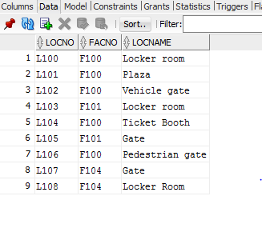
- Deleted
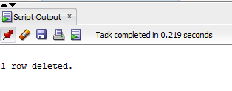
- After(8 rows)(Last row was deleted)
